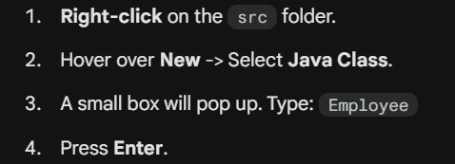
"Factory Line"
Think of a List as a bucket of water (data). Think of a Stream as a pipe connected to that bucket. As data flows through the pipe, you attach "filters" and "transformers" to change the water before it comes out the other end.
The Golden Rule: A Stream does not modify the original list. It creates a new result.
Many beginners think "Java Development = Spring Boot," but Streams are part of Core Java (Java 8 and above).
Spring Boot is a framework used for building web servers. Java Streams are a feature of the language used for data processing.
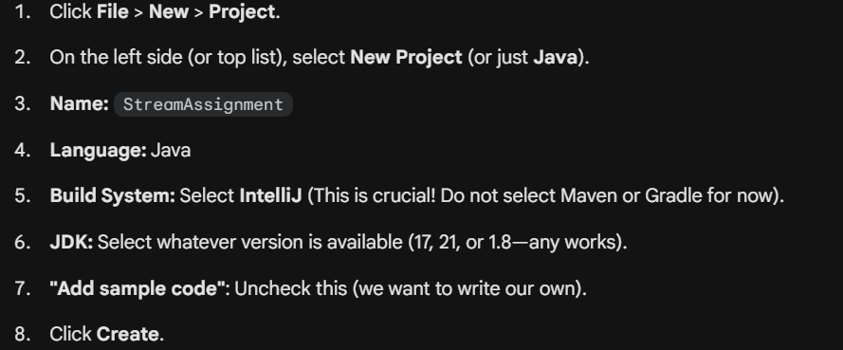

// We make these 'private' so no one can mess with them directly.
// This is "Encapsulation" - a key Clean Code principle.
Streams pipline:
filter → remove unwanted data
- map → transform data
- collect → convert stream back to a list
- forEach → terminal operation
JUnit 5 test:
Java is divided into two parts i.e. Core Java (J2SE) and Advanced Java (JEE)
The core Java part covers the fundamentals (data types, functions, operators, loops, thread, exception handling, etc.)
Whereas Advanced Java covers the standard concepts such as database connectivity, networking, Servlet, web-services, etc.
application servers such as Apache Tomcat and Glassfish
advance Java frameworks like, Spring, Hibernate, Struts, that enables us to develop secure transaction-based web applications such as banking application, inventory management application.
Java's versatility across different computer systems is enabled by the Java Virtual Machine (JVM), which translates Java code into machine-specific instructions.
🧠 Simple mental model (remember this)
Write logic → test logic → add dependencies → mock dependencies
That’s the correct professional order.
Step: Refactor into a Service-style class
🎯 Goal
Move logic out of Main and into a reusable, testable service
Why do we need Mockito at all?
Because real services depend on other components

